Transportation Problems:
Problem 1: ABC Corporation has 3 supply points (manufacturing plants) at LA, Atlanta and NY City and 4 demand points (sales regions) at East, Midwest, South and West. In the manufacturing plants the following are the production and sending capacity:
Plant Name | Capacity (in Units)
LA | 10000
Atlanta | 12000
NY City | 14000
In the sales regions the following are the demands:
Region | Demand (in Units)
East | 9000
Midwest | 6000
South | 6000
West | 13000
The following grid shows the cost of production and shipment from the supply point to demand point:
 | EAST | MIDWEST | SOUTH | WEST
LA | $5.00 | $3.50 | $4.20 | $2.20
ATLANTA | $3.20 | $2.60 | $1.80 | $4.80
NEW YORK CITY | $2.50 | $3.10 | $3.30 | $5.40
Depend upon this scenario, find out how many products (in units) to be produced and send by plants to demand points, where the total production and shipment cost is the minimum. The values will be non-negative and can not be fractions.

Problem 2:
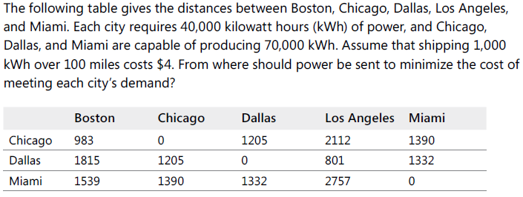

Problem 3:
